Exercise 5
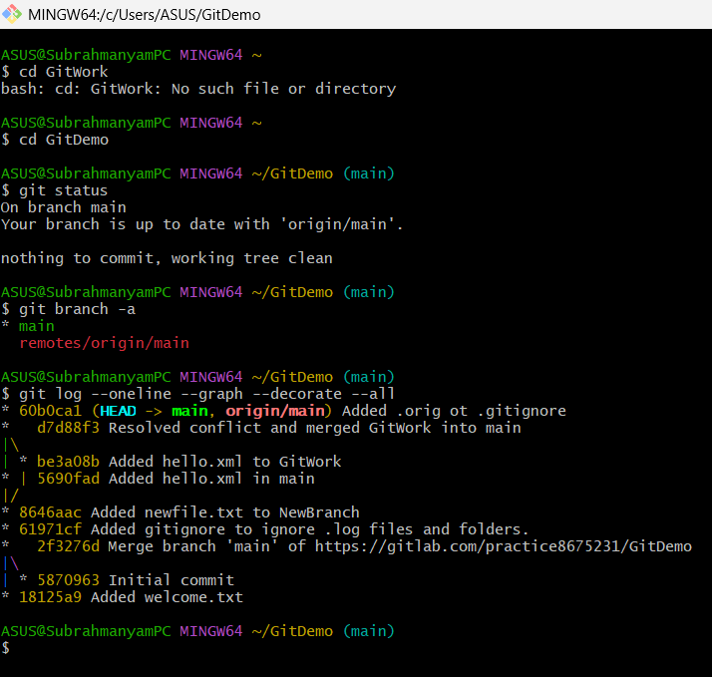

- Verified that main is in clean state
- Only 2 available branches local and remote main, deleted all the newly created branches in previous exercises itself
- Both the remote and local are up-to-date with each other, so this step is not necessary
- I have already pushed changes made in previous exercises, there itself
- There will be no changes in the remote repo, even if I pull and push again.

PTO
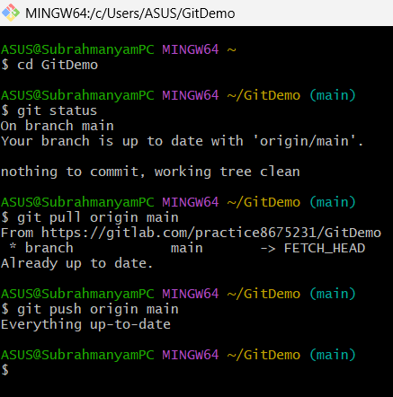

It says everything is up-to-date.

